Lab - Exploring FTP

1. Objectives

Part 1: Use FTP from a Command Prompt

Part 2: Download an FTP File Using WS_FTP LE

Part 3: Use FTP in a Browser

1. Background / Scenario

The File Transfer Protocol (FTP) is part of the TCP/IP suite. FTP is used to transfer files from one network device to another network device. Windows includes an FTP client application that you can execute from the command prompt. There are also free graphical user interface (GUI) versions of FTP that you can download. The GUI versions are easier to use than typing from a command prompt. FTP is frequently used for the transfer of files that may be too large for attachment with an email.

When using FTP, one computer is normally the server and the other computer is the client. When accessing the server from the client, you need to provide a username and password. Some FTP servers have a user named **anonymous**. You can access these types of sites by simply typing “anonymous” for the user, without a password. Usually, the site administrator has files that can be copied but does not allow files to be posted with the anonymous user.

In this lab, you will learn how to use anonymous FTP from the Windows command-line C:\> prompt. You will also use the GUI-based FTP program, WS_FTP LE. Finally, you will use an anonymous FTP in a browser.

1. Required Resources

1 PC (Windows 7, Vista, or XP with access to the command prompt and Internet access and WS_FTP LE installed)

1. Use FTP from a Command Prompt
   * 1. Click the **Windows Start** button, type **cmd** in the search field, and press Enter to open a command window.
     2. At the C:\> prompt type **ftp ftp.cdc.gov**. At the prompt that says **User (ftp.cdc.gov:(none)):** type **anonymous**. For the password, do not type anything. Press Enterto be logged in as an anonymous user.

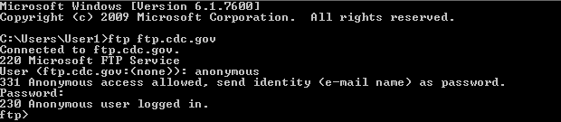

Notice that the C:\> prompt has been replaced with the ftp> prompt. Type **ls** to list the files and directories. At the time that this lab was authored, there was a Readme file.

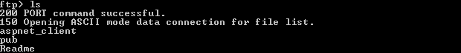

* + 1. At the prompt, type **get Readme**. This downloads the file to your local computer from the anonymous FTP server that the Center for Disease Control has setup. The file will be copied into the directory shown in the C:\> prompt (C:\Users\User1 in this case).

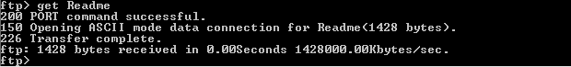

* + 1. Type **quit** to leave FTP and return to the C:\> prompt. Type **more Readme** to see the contents of the document.

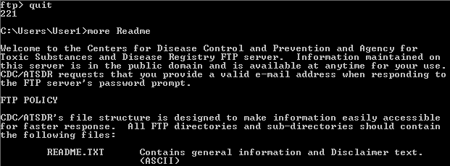

* + 1. What is a drawback of using the FTP from the command line?

____________________________________________________________________________________

1. Download an FTP File Using WS_FTP LE

In Part 2, you will download a file using WS_FTP LE (a free FTP transfer tool).

* + 1. Start **WS_FTP LE**. If the Ipswitch WS_FTP LE window displays, click **Next** to continue and skip to step c. Otherwise, click the **Open a Remote Connection** link.

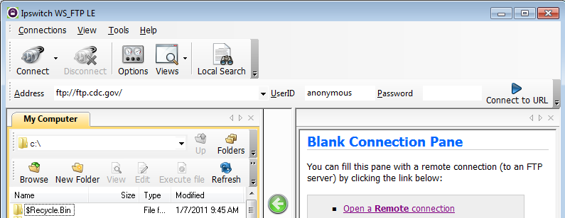

* + 1. Click **Create Site…**.

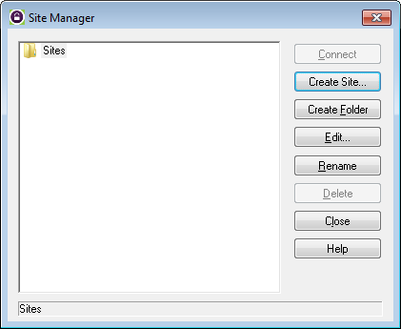

* + 1. In the **Site Name** field, type **Center for Disease Control** and click **Next** to continue.

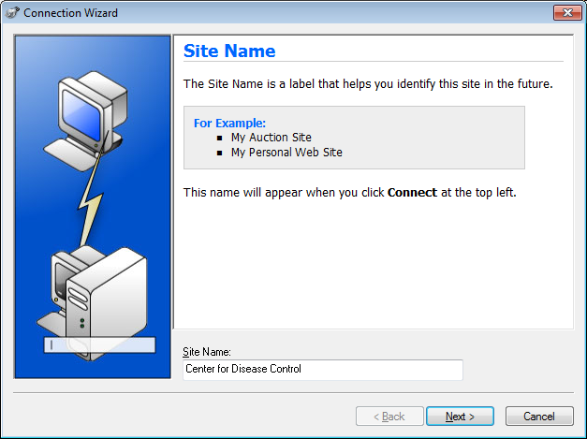

* + 1. Click the **Connection Type** drop-down list, select **FTP** (the default connection type), and click **Next**.

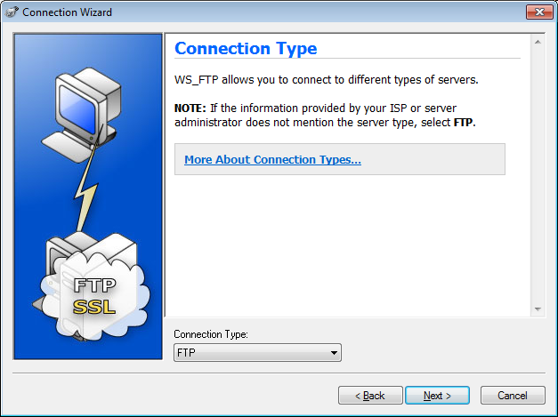

* + 1. In the **Server Address** field, type [**ftp.cdc.gov**](ftp://ftp.cdc.gov),and click **Next**.

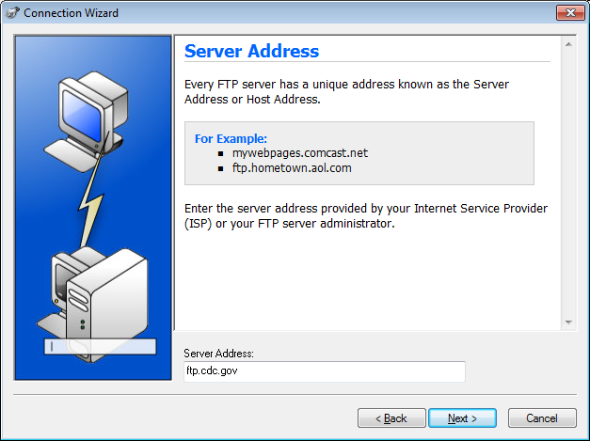

* + 1. In the **User Name** field, type **anonymous**, and leave the password field blank. Click **Next**.

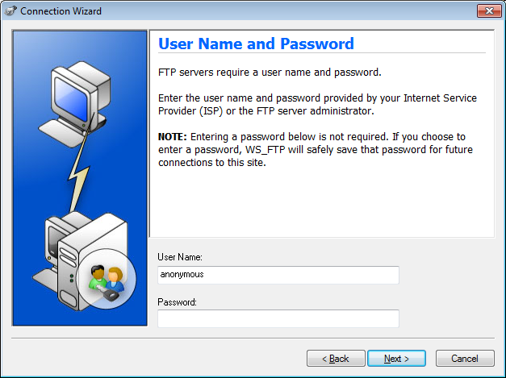

* + 1. Click **Finish**.

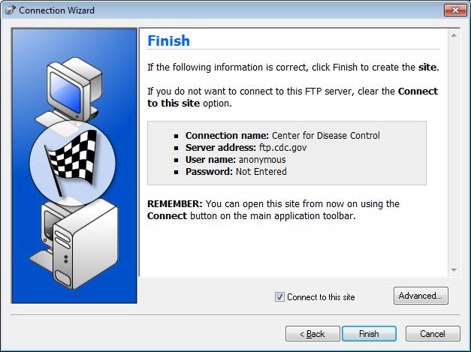

* + 1. When the Login Information Missing dialog box displays, click **OK**. Do not type a password in the **Password** field.

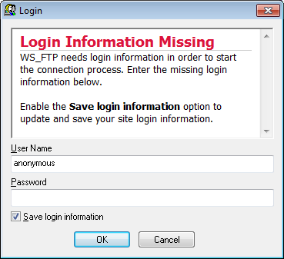

* + 1. You are now anonymously connected to the Center for Disease Control FTP site.

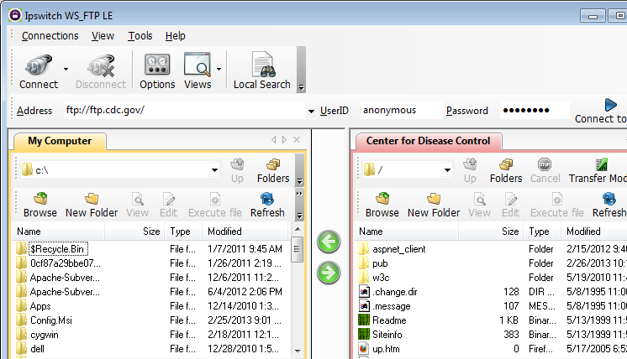

* + 1. On the WS_FTP LE toolbar menu under My Computer, click **New Folder** to create a folder on your local **C:\** drive.
    2. In the Make Directory dialog box name the folder as **CDC** and click **OK**.

**Note:** If the folder already exists, you can use the same folder or create another folder with a different name. If using the same CDC folder, you can replace the existing Readme file with the downloaded Readme file.

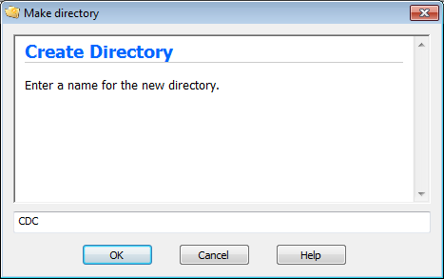

* + 1. After the directory is created, in the **My Computer** tab page, double-click the directory to open it.

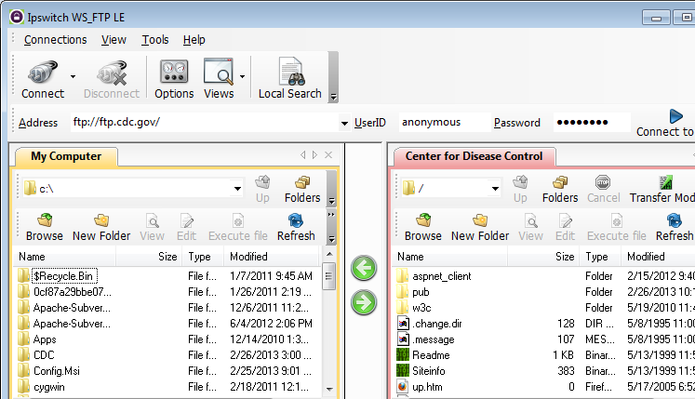

* + 1. Drag the file **Readme** from the right side of the application (the remote CDC FTP server) into the CDC folder on to the local **C:\** drive.

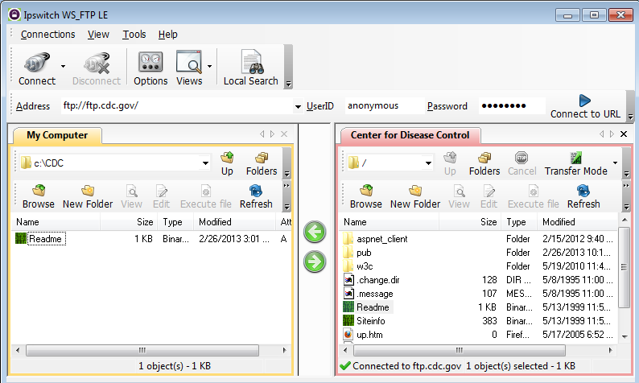

* + 1. Double-click the **Readme** file in the **C:\CDC** folder on your local **C:\** drive. If prompted for an application to open the document, choose any word processing software. You should see a message that looks something like this:

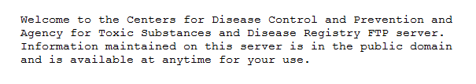

* + 1. Which was easier, using FTP from the **cmd** prompt, or using WS_FTP LE? ________________________
    2. Click **Disconnect** to disconnect from the [ftp.cdc.gov](ftp://ftp.cdc.gov) site when finished.
    3. The remote site will be removed from the saved list of FTP sites. In the Ipswitch WS_FTP LE window, click the **Open a Remote Connection** link. Select the **Center for Disease Control** site, and click **Delete** to remove the FTP site. Click **Yes** to confirm the deletion. Click **Close** to exit the Site Manager.
    4. Remove the **C:\CDC** folder.

1. Use FTP in a Browser

It is possible to use a browser as an anonymous FTP client.

* + 1. In a browser, type [**ftp://ftp.cdc.gov/**](ftp://ftp.cdc.gov/).

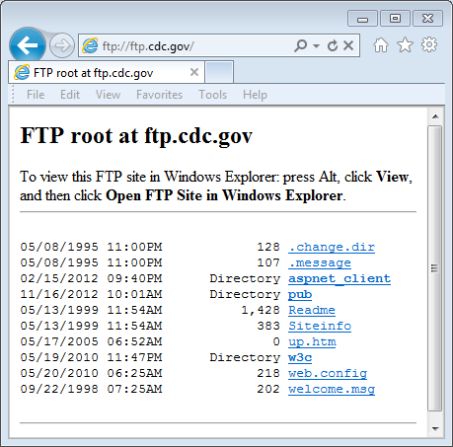

* + 1. Click the **Readme** file.

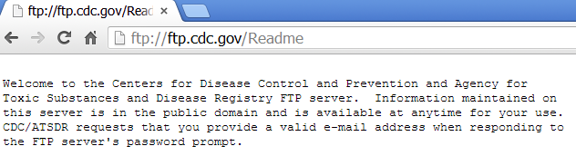

1. Reflection
   1. Which FTP method was easiest to use?

_______________________________________________________________________________________

* 1. Was there any advantage to using FTP from the command prompt or using WS_FTP LE?

_______________________________________________________________________________________

_______________________________________________________________________________________

_______________________________________________________________________________________